Technical Design Template

Team: | Phantom | ITN: | 4 |  |  | Solution Design
 |  | Pipeline(s):
  MH6

Team: 1
ITN: 1
Solution Design 1
Pipeline(s): 1
1 Introduction 1
1.1 Link to Requirements Document 1
1.2 Requirements 1
User Story 1
2 Design Discussion 2
2.1 Use Case 2
2.2 Class Diagrams 2
3 Implementation 3
3.1 Files 3
4 Testing Considerations 8
5 Screenshots 9

Introduction
This is a web-based application used to manage the contacts for a firm. The contacts are stored in a secure location on an internal server and the user is able to log in to the system using their access details.
The user can perform CRUD operations based on the privileges provided to them by the administrator.

Link to Requirements Document
https://jira2.cerner.com/browse/DEVACDMY-5165

Requirements
.

User Story
User Story ID | MH6
Story | Update person details
Description | The user is able to make changes to the person details.

Design Discussion

Use Case
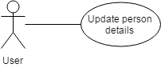
Figure 1 Use Case for updating person details

2.2 Class Diagrams

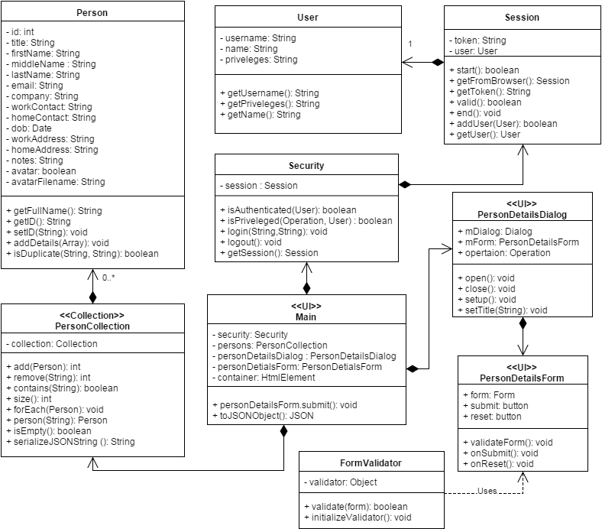
Figure 2 Class Diagram for adding contact

Implementation

This user story is to allow the user to update the person details and save it. The implementation details are as follows:

- The list of persons is stored in a collection object called PersonCollection.
- When the user selects a person, the person details are fetched from the collection corresponding to the id of the selected person.
- A dialog containing the form to show the details of the person is opened.
- The form is populated with the person details fetched and shown to the user.
- The dialog form consists of fields that are mandatory and some are optional.
- The user can update the person details using the keyboard.
- The jQuery validation plugin is used to validate the input given in the fields.
- The validation rules are as follows:
- The title, first name, last name, work contact and the email are mandatory fields while the rest are optional.
- Email address should be a valid email address.
- The work and home contact numbers should be digits and no letters.
- The date of birth should be in proper format.
- The notes field is incorporated to store any other relevant information about the person.
- The clear all button can be used to clear up all the fields and get a blank form.
- The validation functions are called upon the key up event of the keyboard and the focus out event of the html element. On clicking the submit button, the validation script is called on all the elements.
- The invalidated fields are marked with ‘error_msg’ class which is used by the css file to highlight those fields.
- When the user clicks on the save button and the form is valid, the corresponding person details stored in the persons collection are updated.

Files
3.1.1 HTML

File | listPersons.html
Description | This is the home page where the user lands after successful authentication. It is the dashboard fir the user to add, view, update and delete contact and their details.
3.1.2 CSS

File | css/home.css
Description | It is the css file for the “home.html” page defines the styling for the various html elements.

3.1.3 JAVASCRIPT

File | scripts/js/Main.js
Description | This class creates the objects for the application and sets up the click and submit events. It directly deals with UI elements to implement business logic.
Pseudo Code | personDetailsForm.submit(function(event){  //serialize form information into JSON  var personJSON = $(this).serializeObject();  //duplicate record check  var duplicateFound = false;  persons.forEach(function(person){  // do not compare with self record  if(person.id != personJSON.id){  if(person.isDuplicate( personJSON.email, personJSON.workContact)){  duplicateFound = true;  }  }  });  if(duplicateFound){  //show a that given email/workContact already exists  $('#message').html(message);  }else{  var personObj = new Person(personJSON.id);  personObj.addDetails(personJSON);  persons.add(personObj);  personDetailsDialog.close();  }  //repopulate list  populatePersonsOnUI(persons, container, personDetailsDialog );  });
Passive (Yes/No) | Yes

File | scripts/js/PersonDetailsDialog.js
Description | This class is the representation of the html dialog on the UI.
Pseudo Code | function open (){  this.mDialog.dialog('open');  }  function close(){  this.mDialog.dialog('close');  }
Passive (Yes/No) | Yes

File | scripts/js/PersonDetailsForm.js
Description | This class is the representation of the html form on the UI.
Pseudo Code | function reset (){  this.resetForm();  this.formValidator.removeErrorMessages();  $('.ui-state-highlight').removeClass('ui-state-highlight');  $('#message').html('');  }
Passive (Yes/No) | Yes

File | scripts/js/FormValidator.js
Description | This class is the form validator that validates the data entered by the user into the input fields.
Pseudo Code | class FormValidator = {  function initializeValidator(){  $.validator.setDefaults({  highlight: function(input) {  $(input).addClass("ui-state-highlight");  $(input).addClass("ui-element-state-error");  },  unhighlight: function(input) {  $(input).removeClass("ui-state-highlight");  $(input).removeClass("ui-element-state-error");  },  errorClass: 'error_msg',  wrapper : 'td',  errorPlacement : function(error, element) {  error.addClass('ui-state-error');  error.prepend('<span class="ui-icon ui-icon-alert"></span>')  var thirdCol = element.closest('td').nextAll('.third-col');  error.appendTo(thirdCol);//.effect('highlight', {}, 2000)  }  });  }  }
Passive (Yes/No) | Yes

File | scripts/php/Person.js
Description | This class defines the person object along with a function add the person details.
Pseudo Code | function addDetails (fields){  // for each key in array add to this['fieldname']  for(var field in fields){  if(fields[field] == null) fields[field]="";  this[field] = fields[field];  }  }
Passive (Yes/No) | Yes

File | scripts/php/PersonCollection.js
Description | This class is an implementation of the Collection class. It is a collection of persons and defines functions that are required for a collection.
Pseudo Code | class PersonCollection(){  this.collection = new Collection();  this.add = function(person){  this.collection.add(person.getID(), person);  return this.collection.getCount();  }  this.remove = function(id){  this.collection.remove(id);  return this.collection.getCount();  }  this.contains = function(id){  return this.collection.contains(id);  }  this.size = function(){  return this.collection.getCount();  }  this.isEmpty = function(){  return this.collection.isEmpty();  }  }
Passive (Yes/No) | Yes

File | scripts/js/User.js
Description | This class is the definition of a real-user of the application and contains user-related info like username, name, privileges etc.

File | scripts/js/Session.js
Description | This is the class that store the current session and the user associated with the session
Pseudo Code | function valid(){  request = new Request();  validateSessionEventHandler = new RequestEventHandler();  coordinator = new UICoordinator();  coordinator.sendRequest(req, validateSessionEventHandler );  if(validateSessionEventHandler.success)  return true;  else  return false;  }  }

File | scripts/js/Security.js
Description | This class is responsible for authentication and validating session and privileges. It sends a request to the server for login() and logout() respectively
Pseudo Code | function isAuthenticated(user){  if(user.session == null) return false;  else{  return user.session.validate();  }  }  function isPriveleged(operation, user){  switch(operation){  case Operation.FETCH_LIST:  case Operation.FETCH_DETAILS:  case Operation.READ:  if(user.priveleges.search('r') != -1) return true;  case Operation.ADD:  case Operation.EDIT:  case Operation.DELETE:  if(user.priveleges.search('w') != -1) return true;  default:  return false;  }  }

Testing Considerations
Navigate to the listPersons.html and follow the steps given below for each test case.

#Test Cases | Test Steps | Expected Results
TC 1 | - Click on a person photo/box | A dialog window appears with a form to update person details.
TC 2 | - Click on a person photo/box  - Click on the save button | If the form is valid, the changes are updated and can be verified by re-clicking the person
TC 3 | - Enter less than three characters in the first name field | An error message displays saying “Please enter atleast three characters”
TC 4 | - Enter an invalid email address | An error message displays saying “Please enter a valid email address.”
TC 5 | - Enter an invalid date in dob field | An error message displays saying “Please enter a valid date.”
TC 6 | - Enter alphabets in work contact or home contact. | An error message displays saying “Please enter only digits.”
TC 7 | - Click on a person photo/box  - Fill up the required fields appropriately  - Click on ‘Clear all’ button | The form inputs are cleared and the form is reset
TC8 | - Click on a person photo/box  - Enter a valid duplicate email | An error message displays saying “Given email already exists”
TC9 | - Click on a person photo/box  - Enter a valid duplicate work contact | An error message displays saying “Given work contact already exists”
TC10 | - Click on a person photo/box  - Make changes to the details  - Close the dialog box | A confirmation dialog box appears saying “Are you sure you want to close without saving changes?”

Screenshots
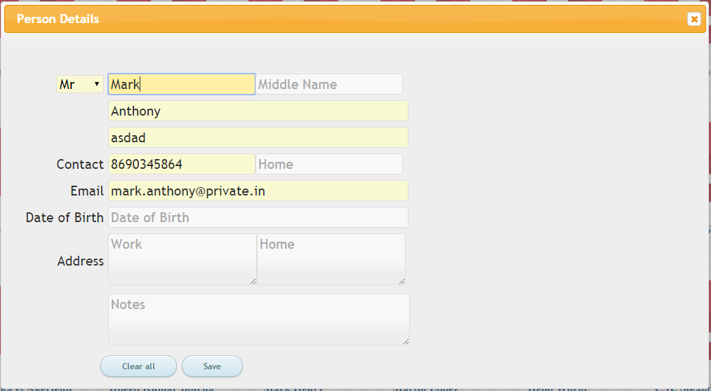
Figure 3 Dialog form to update person details

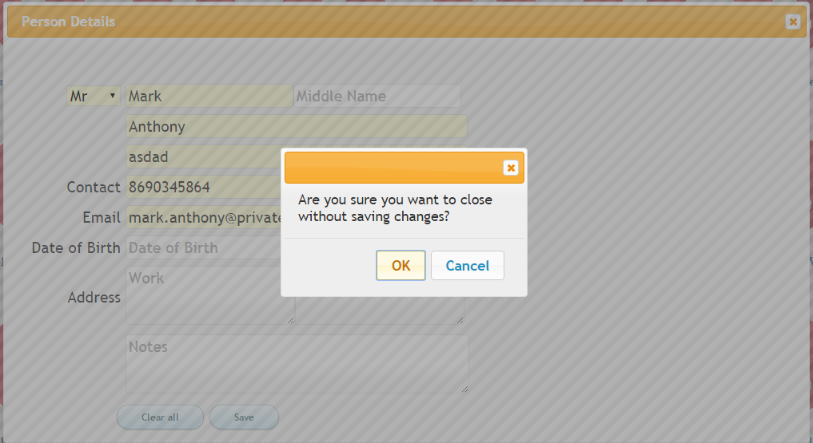
Figure 4 Confirmation dialog when closing without saving changes

